**PART 3: BACK-END DEVELOPMENT FROM REQUIREMENTS**

**Booking CRUD operation forms (Make Booking Form)**

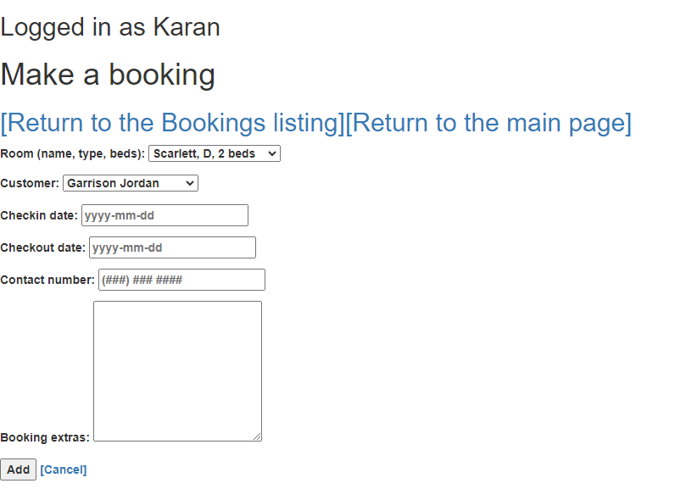

**List of Bookings**

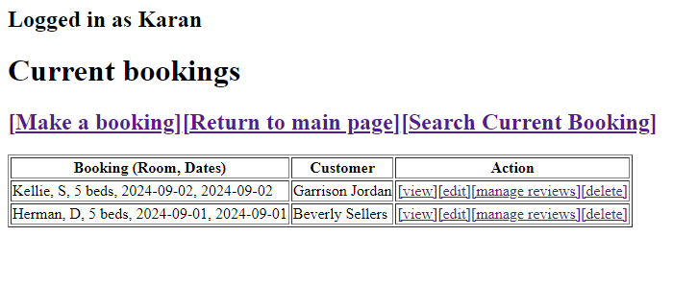

**View Specific Booking**

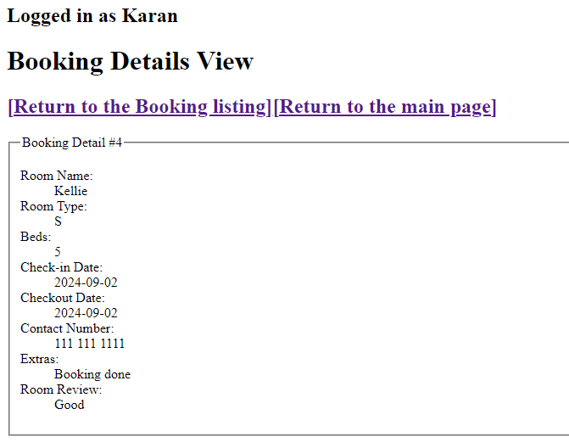

**Edit Specific Booking**

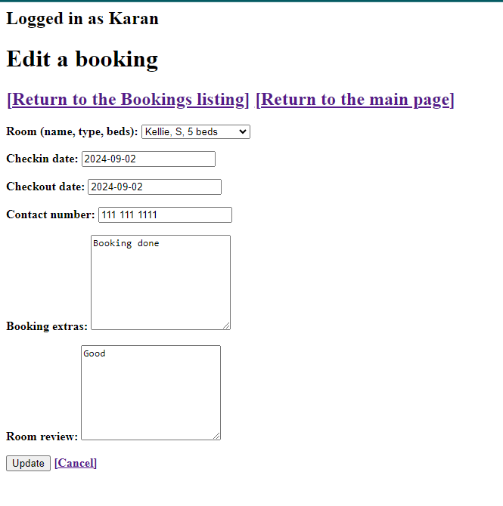

**Edit or ADD Room review for specific booking**

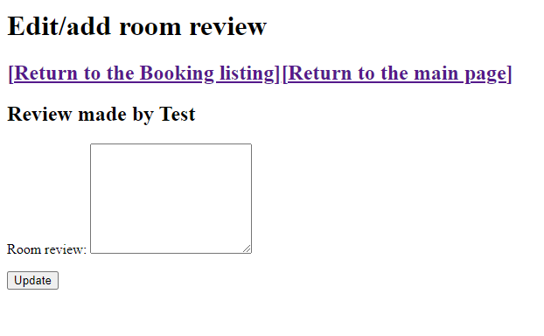

**Booking Preview after deletion**

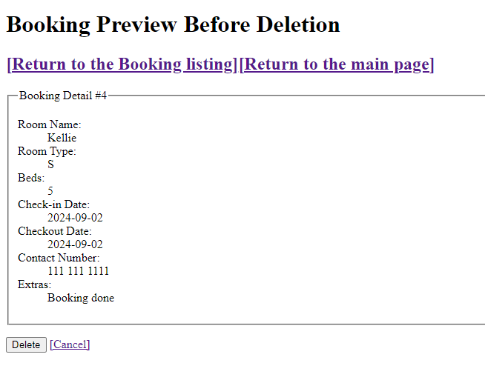

**AJAX Implementation in Make Booking Page**

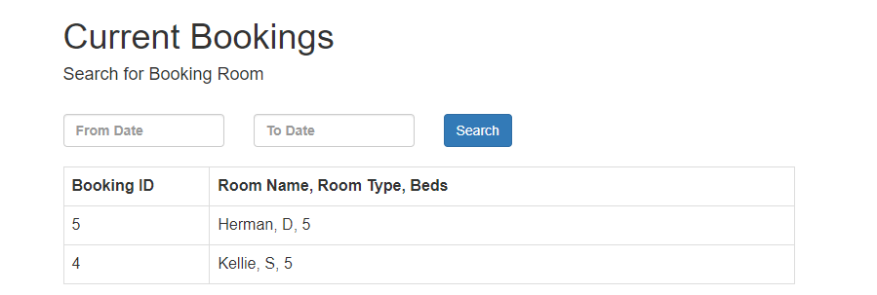

**Admin Login Page Created with Session implementation**

**Username: Karan**

**Password: Karan**

**Database table name Users**